**PROJECT REPORT TEMPLATE**

**1.INTRODUTION:**

* 1. Overview

Our project is designing a logo. We did it using canva.

* 1. Purpose

We did this project to practically work on canva after acquiring knowledge the canva skills.

**2.PROBLEM DEFINITION & DESIGN THINKING:**

2.1 Empathy map

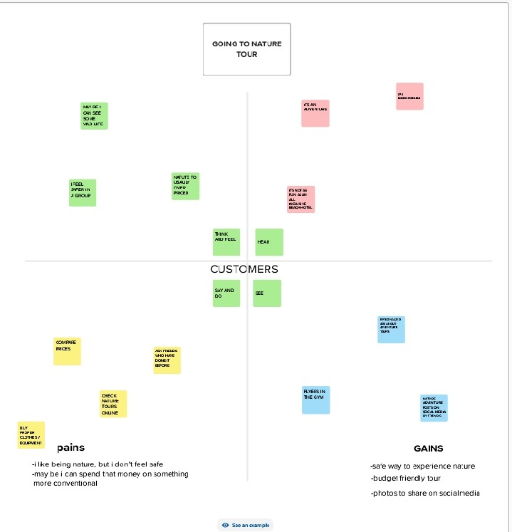

2.2 Ideation & Brainstorming:

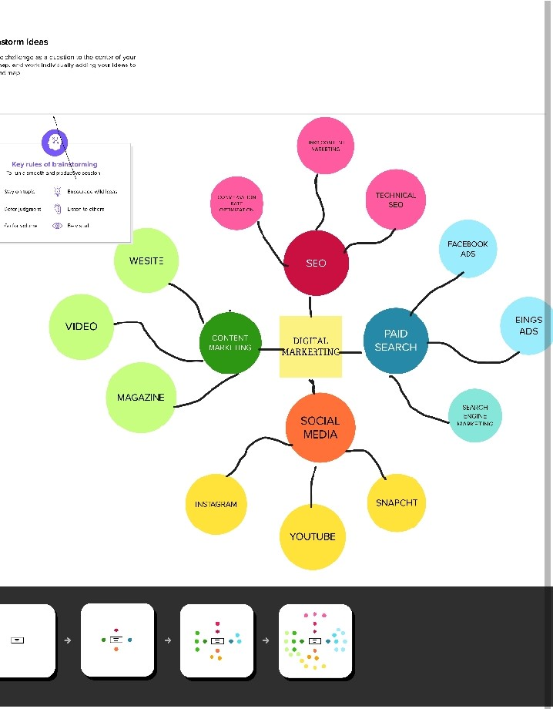

**3.RESULT:**

We have attached the result in previous file.

**4.ADVANTAGES AND DISADVANTAGES:**

Through this canva design, we came to finish big tasks in just a single tap. It was time -saving.

**5.APPLICATIONS:**

This is useful for making resumes,certificates,infographics,etc…

**6.CONCLUSION:**

We have learnt to use the canva design and make our works easier. We have learnt to design our own invitations,resumes,etc…